**CSCE 5350: Fundamentals of Database System**

**Quiz Management System**

**Project Report**

**Instructor:** Dr. Nirosha Dinayadura

**Date:** 19 April 2024

**Team Members:**

|  |  |
| --- | --- |
| Name | EUID |
| Kishan Kumar Zalavadia | 11685261 |
| Uday Bhaskar Valapadasu | 11696364 |
| Sapthagiri Naik Bhukya | 11699072 |

**Table of Contents:**

|  |  |  |
| --- | --- | --- |
| S.No. | Title | Page No. |
| 1 | Abstract | 3 |
| 2 | Introduction | 3 |
| 3 | System Analysis | 3 |
| 3.1 | Database Design | 3 |
| 3.2 | Relational Scheme | 4 |
| 3.3 | Normalization | 9 |
| 4 | Implementation | 9 |
| 4.1 | Technologies Used | 9 |
| 4.2 | How to run? | 10 |
| 4.3 | Code Snippet | 12 |
| 5 | Results and Discussions | 12 |
| 5.1 | Functionalities | 12 |
| 5.2 | Assumptions | 13 |
| 5.3 | Challenges | 13 |
| 5.4 | Application Walk-through | 13 |
| 6 | Conclusion | 30 |

**1. Abstract:**

Our main objective in developing this project is to gain a deep understanding of database schema structures and apply this knowledge to create a real-time quiz management system application. By designing and implementing an interconnected **Entity-Relationship (ER)** diagram within the system's database, we aim to address practical challenges in educational assessments. This hands-on experience will enhance our comprehension of how databases manage complex relationships and transactions in an actual application environment, while also providing a user-friendly platform for both educators and students to conduct and participate in quizzes seamlessly.

**2. Introduction:**

The quiz management system is designed to improve the assessment process. This system is easy to use and has benefits like tracking the quiz history. Professors can easily conduct quizzes with multiple attempts. And the students can take quizzes conveniently. This system’s database consists of 17 tables which are interconnected. Our system gives a very convenient UI which makes it attractive to use.

**3. System Analysis:**

**3.1 Database design** (Entity Relationship Diagram):

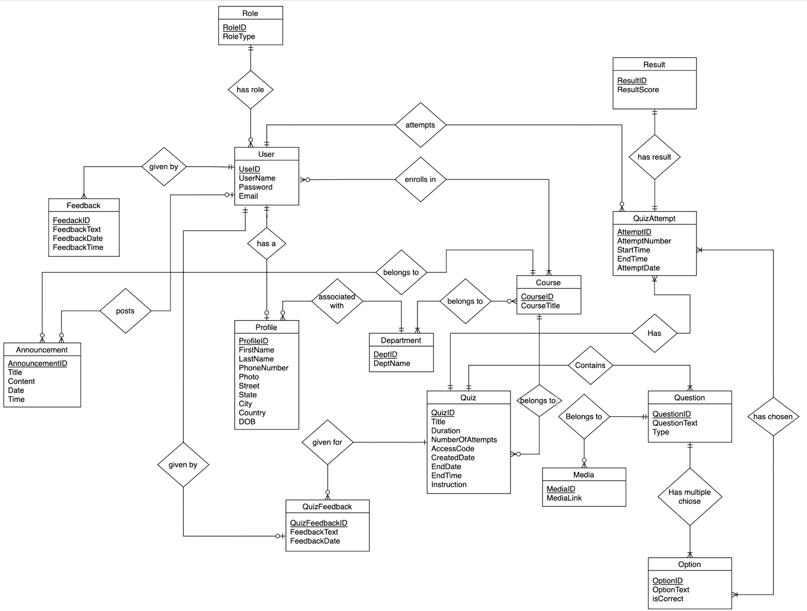

**3.2. Relational Schema**

Below are the entities of the Quiz Management System

1. User
2. Profile
3. Role
4. Feedback
5. Department
6. Course
7. User_Course
8. Department_Course
9. Quiz
10. Quiz_Feedback
11. Question
12. Option
13. Media
14. Attempts
15. Quiz_Attempt_Option
16. Result
17. Announcement

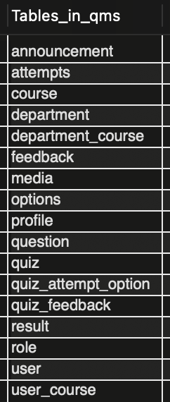

1. **User**

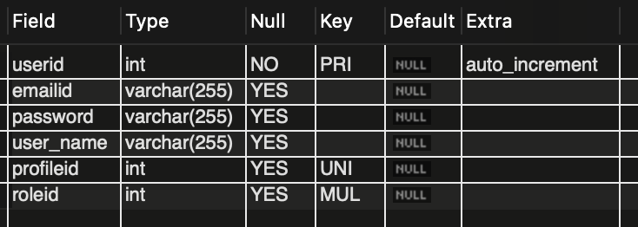

1. **Profile**

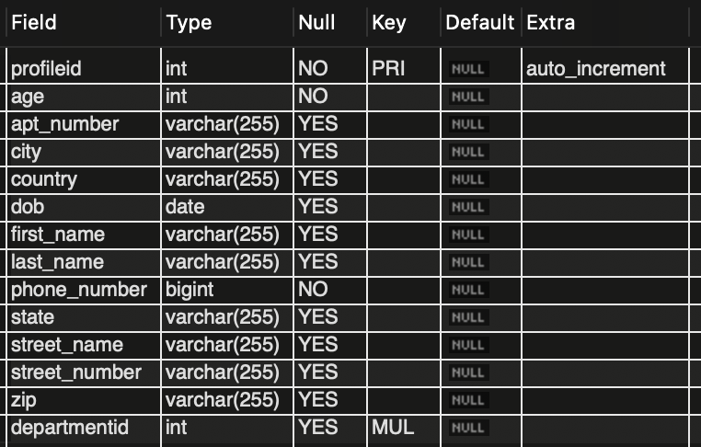

1. **Role**

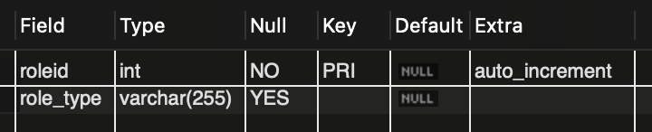

1. **Feedback**

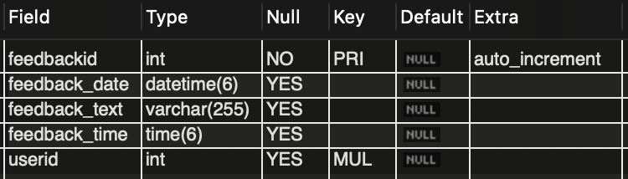

1. **Department**

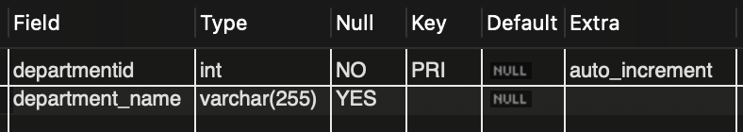

1. **Course**

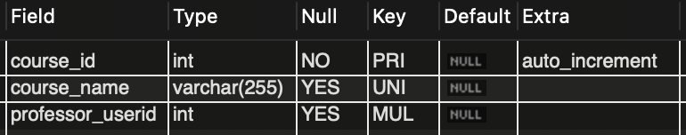

1. **User_Course**

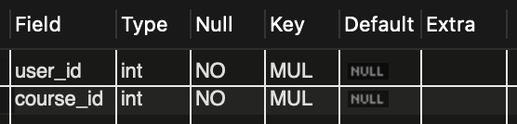

1. **Department_Course**

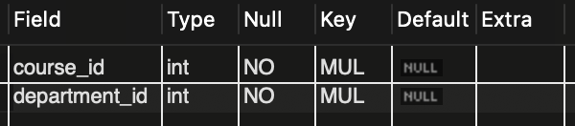

1. **Quiz**

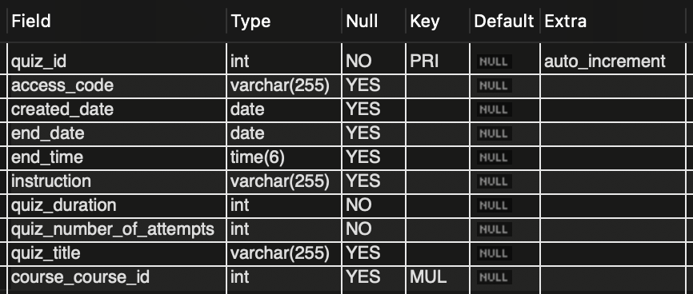

1. **Quiz_Feedback**

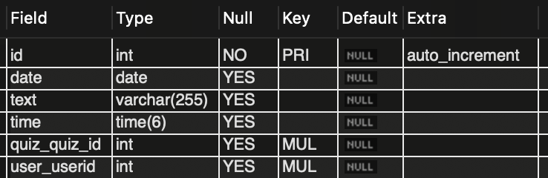

1. **Question**

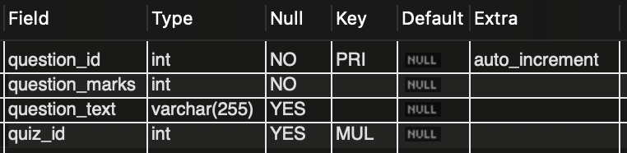

1. **Options**

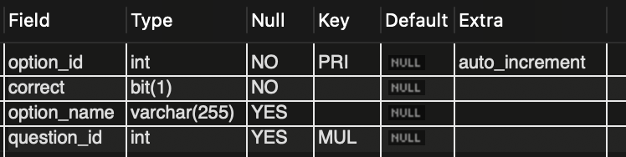

1. **Media**

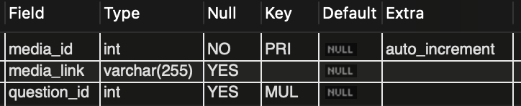

1. **Attempts**

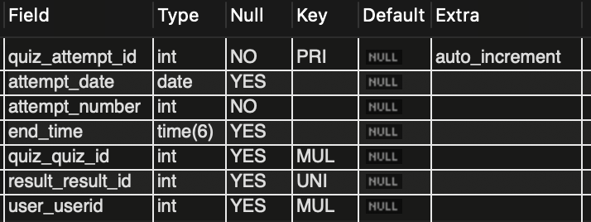

1. **Quiz_Attempt_Option**

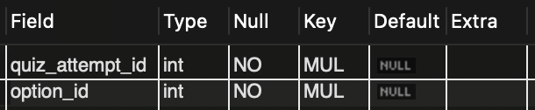

1. **Result**

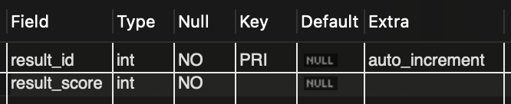

1. **Announcement**

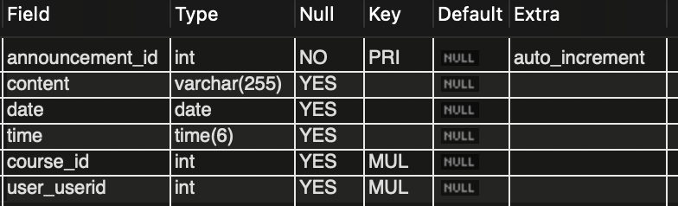

**3.3. Normalization:**

In the context of normalization:

**1. First Normal Form (1NF):**

* Each table in our relational schema has a unique primary key attribute, ensuring that each record can be identified uniquely.
* Every piece of data in our tables is atomic, meaning it cannot be further divided. Therefore, our tables are already in 1st normal form.

**2. Second Normal Form (2NF):**

* All non-prime attributes (attributes not part of the primary key) are fully dependent on the primary key.
* We have eliminated partial dependencies in our relations, ensuring that each non-prime attribute is directly related to the primary key. Hence, our tables are already in 2nd normal form.

**3. Third Normal Form (3NF):**

* Our relations do not contain non-prime attributes that depend on other non-prime attributes, which, in turn, are dependent on the primary key.
* There are no transitive dependencies; all non-prime attributes are fully dependent on the primary key.
* Therefore, our relations are already in 3rd normal form.

In summary, our database design meets the criteria of 1NF, 2NF, and 3NF, indicating a high level of normalization, and no further normalization is deemed necessary.

**4. Implementation:**

**4.1. Technologies Used:**

* **Frontend:** Angular, HTML, SCSS, TypeScript
* **Backend:** Spring Boot, Java
* **Database:** MySQL
* **IDE:** Visual Studio Code (frontend), IntelliJ IDE (backend), and MySQL Workbench (Database)

**4.2. How to run?**

Below are the instructions to run the project.

**Step 1:** **Download the project**

The project can be found in the following places

* Canvas Submission
* GitHub: <https://github.com/Kishan-Kumar-Zalavadia/FDB_Quiz_Management_System>

**Step 2: Open the project**

* The main folder contains 2 subfolders – frontend and backend.
* Open the frontend folder in VS Code and the backend folder in IntelliJ or Eclipse IDE’s

**Step 3: Setup the project**

* In the application.properties file change the username and password according to your local SQL credentials. (As shown below)

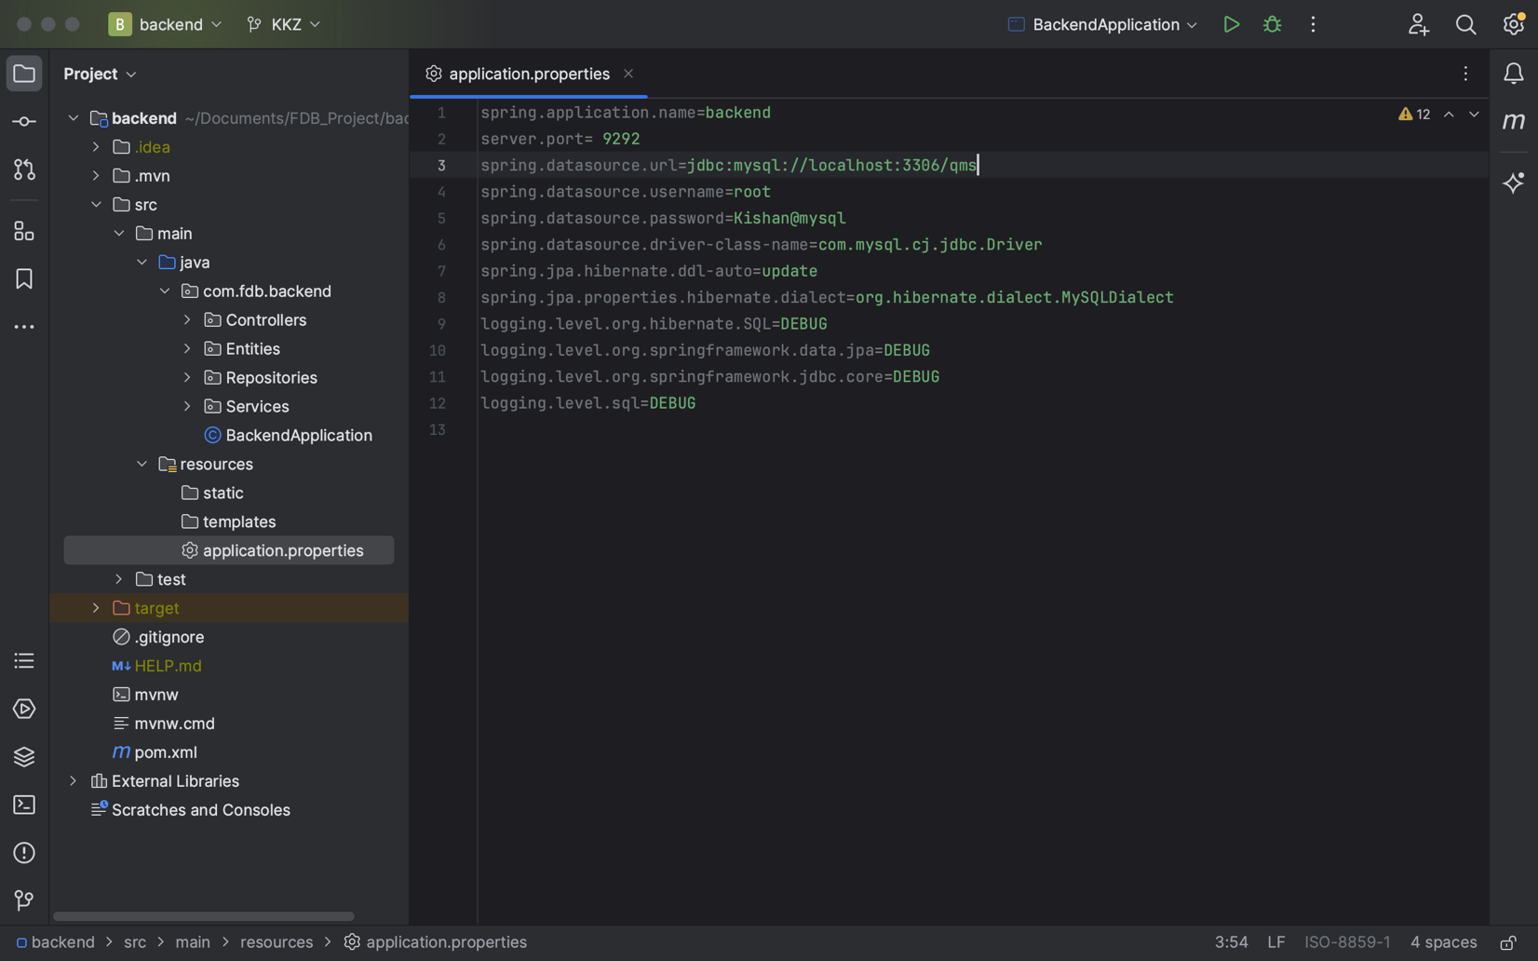

**Step 4: Setup Database**

* Create a MySQL database named ‘*qms’* in your local system.
* Use the command ‘create database QMS’ to do so.

**Step 5: Run the** **backend**

* Run the ‘*BackendApplication.java’* file.
* Click on the triangle sign beside ‘*public class BackendApplication’* to run the Java file. (As shown below)

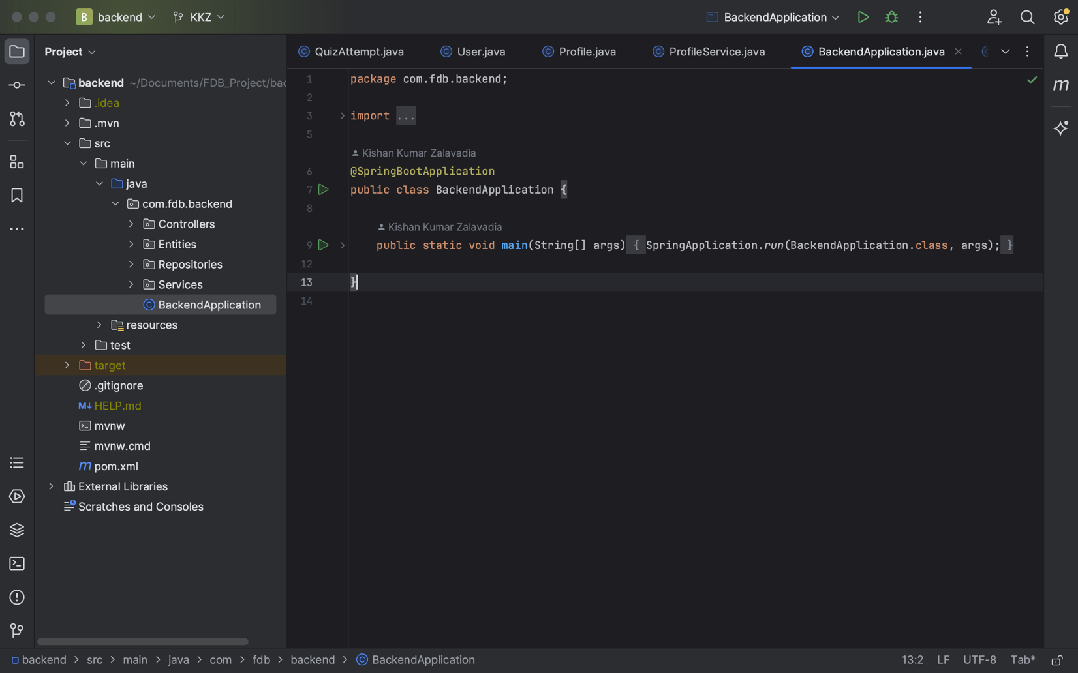

**Step 6: Load sample data**

* Run the commands given in the ‘*SampleData.sql*’ file.
* NOTE: Make sure to have the Role and Department table filled with data present to *‘SmapleData.sql’*.
* NOTE: The queries will not run until the backend is running without any errors.

**Step 7: Run fronted**

* In the terminal type the command *‘ng serve’* to run the frontend.
* Make sure to be inside the ‘frontend’ folder while entering the command’.

**Step 8: View the project**

* To view the project, go to any browser and enter the following URL. (Project URL: <http://localhost:4200/login>)
* NOTE: For these credentials to work, you must have loaded the SQL data as shown in step 6.

**4.3. Code Snippets**

Below is a complex query used in the project:

* SELECT MAX(qa.attemptNumber) FROM QuizAttempt qa WHERE qa.user.userID = :userId AND qa.quiz.quizId = :quizId"

**5. Results and Discussions:**

**5.1. Functionalities:**

* Instructors and Students can create accounts.
* Instructors and Students can log in to their respective accounts using email and password.
* Instructors can create their own courses.
* Students can enroll in courses created by instructors.
* Instructors and Students can give feedback about this application.
* Instructors can create several quizzes for their courses.
* For each quiz, the instructor can add multiple questions each with a different weightage (marks)
* For each question, the instructor can add multiple options. There is no limit to how many options can a question have.
* For each question, the instructor can also add multiple media (Images)
* Students can take quizzes for those courses in which they have enrolled.
* Students can see the number of attempts left for each quiz.
* Students can view their marks after each quiz.
* Students can see the attempt histories which include marks, time, and date of attempt.
* Instructors can see the score of each student for the quiz that they have created. Instructors can also see each score of different attempts of all the students.
* Students can give feedback for each quiz separately.
* Instructors can see all the feedback given by students for the quiz that they have created.
* Instructors can create announcements for courses separately.
* Students can see announcements for the course separately including data and time of announcement.

**5.2. Assumptions:**

* Role and Department are already mentioned.
* Only one profile is associated with each user.
* Users can give one or more feedback.
* Each user has only one role.
* One course can belong to multiple departments and vice versa.
* Users can give one or more feedback on a quiz.
* Each profile is associated with only one department.
* Each Quiz belongs to a course.

**5.3. Challenges:**

One of the major challenges faced during the project is the infinite repetition of data during cardinalities.

For example, the user table has a one-to-one relationship with the profile table. Because we used spring boot, we can have a profile object in the user object and a user object in the profile object. In that case, the data gets trapped infinitely when reading the data from the database.

To overcome this challenge we have used a spring boot annotation ‘@JSONIgnore’ which ignores one of the objects to avoid an infinite loop.

**5.4. Application Walkthrough:**

**Register Page:**

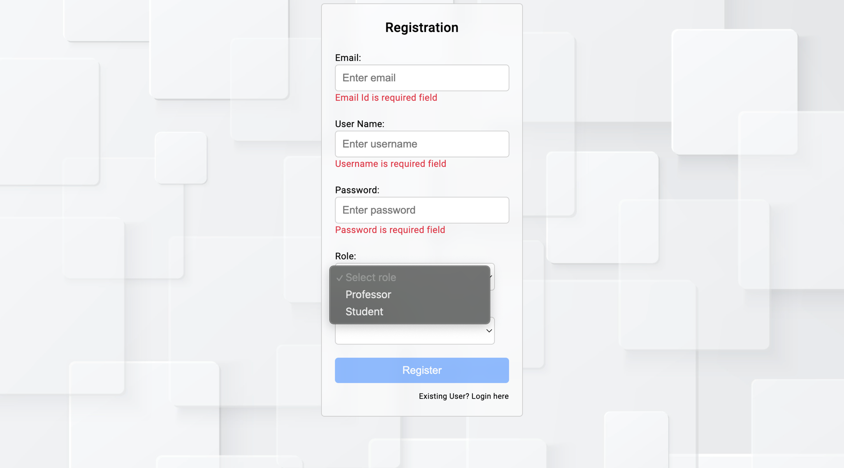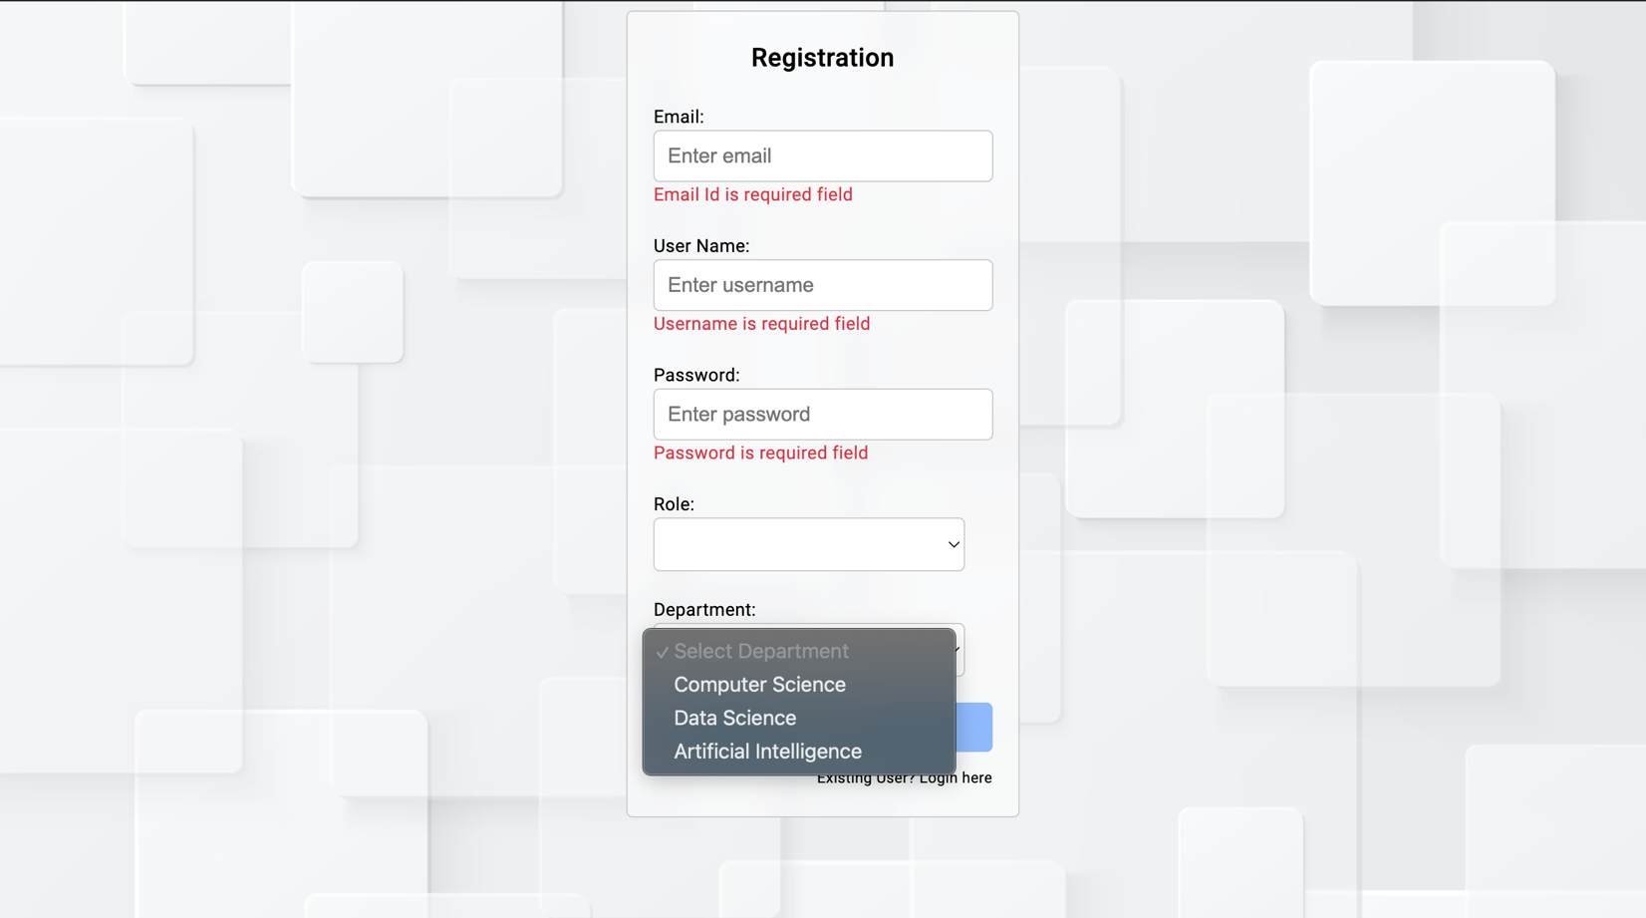

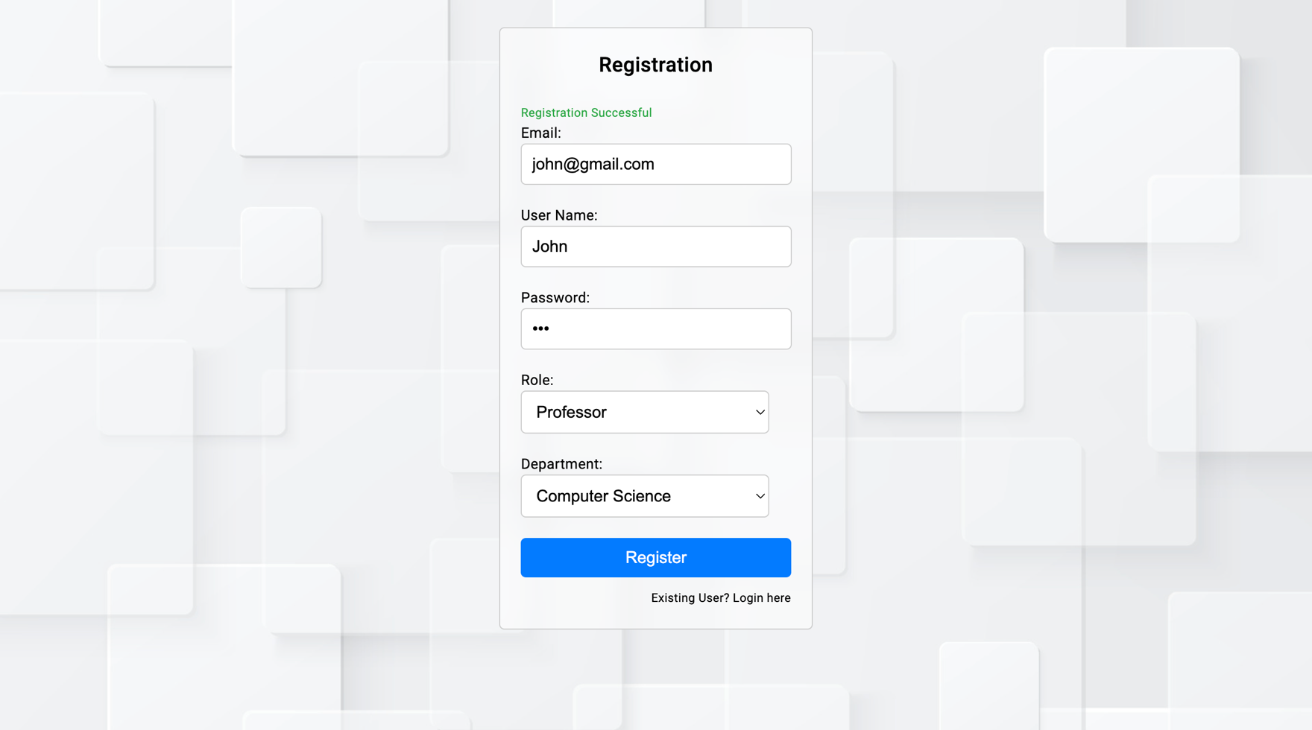

* Users can register as different roles and select the department he/she is in.
* Used is required to fill in all the details, and once registration is successful “Registration Successful” message will be shown in green color.

**Login Page:**

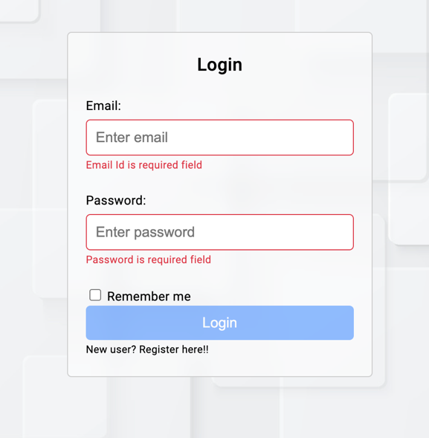

* Once the user has successfully registered, he can log in using the email and password that he used while registering.

**Home Page:**

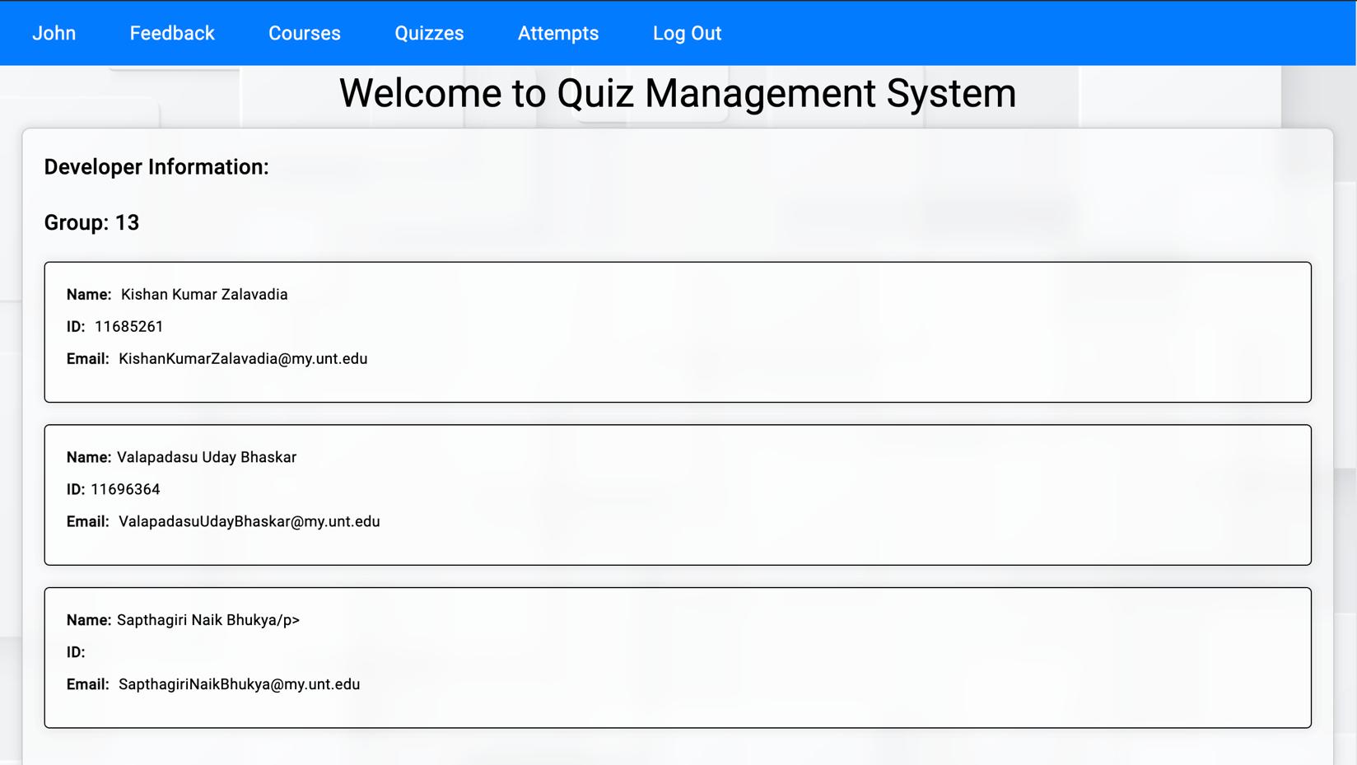

* On the home page user can see his username in the top-left corner.

**Profile Page:**

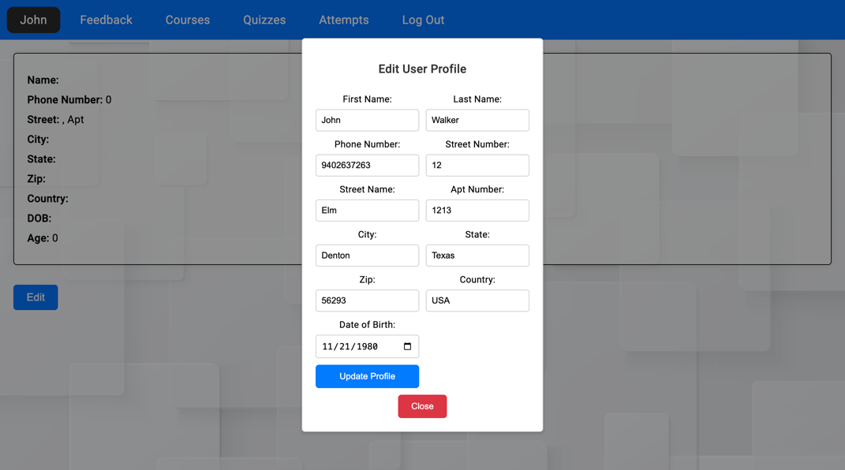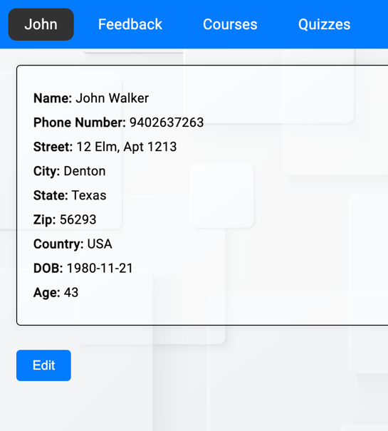

* Users can edit or update their profile at any time.

**Feedback Page:**

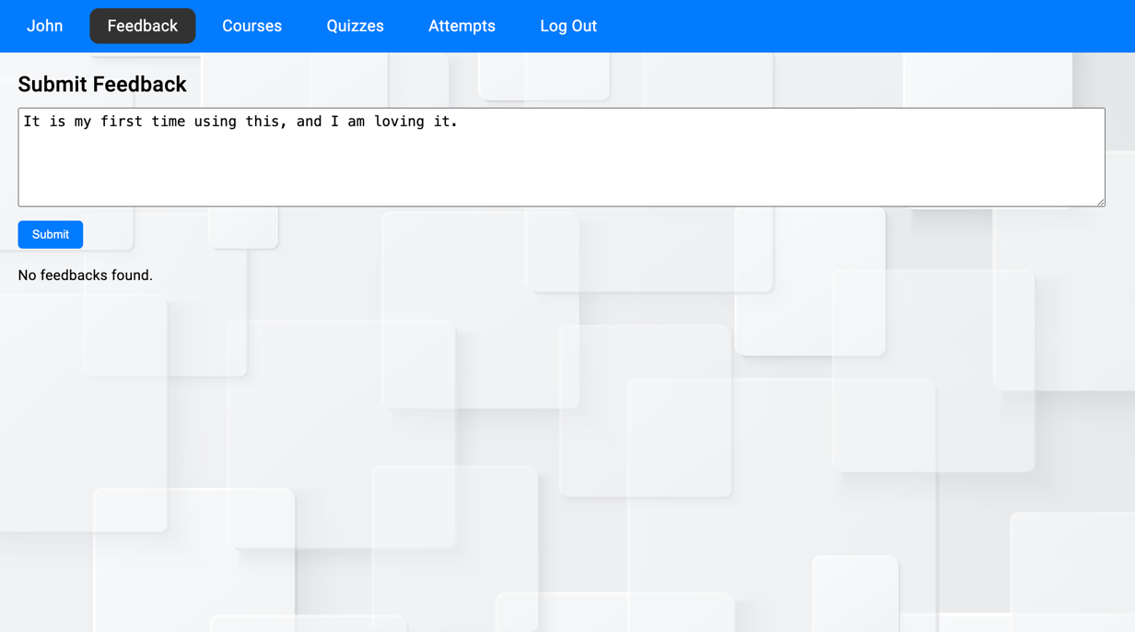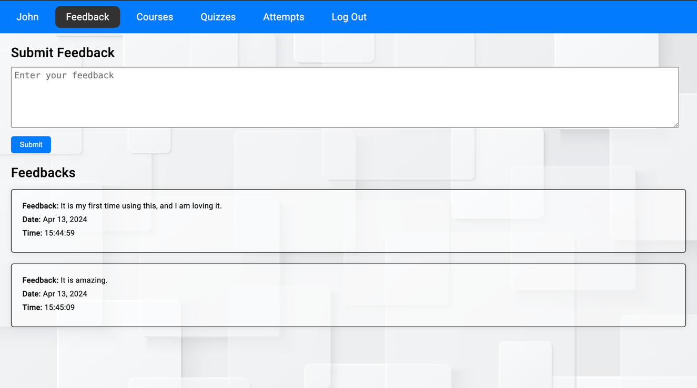

* Users can give feedback and can see all the feedback given by them along with the date and time.

**Add Courses (Professor)**

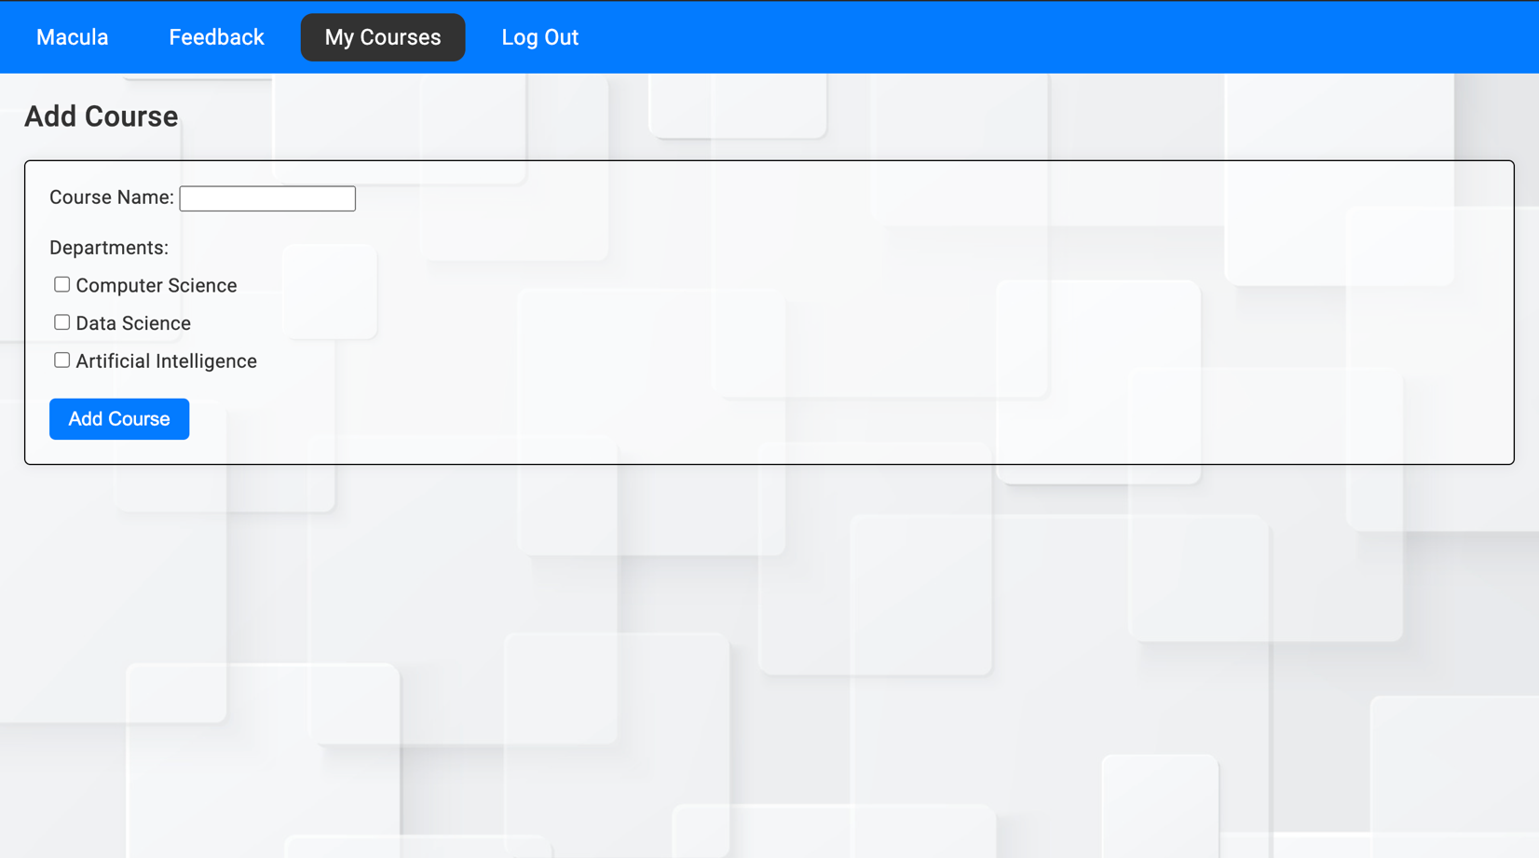

* If the user is a professor, then he/she can add the course and can also choose which department students can take the course.

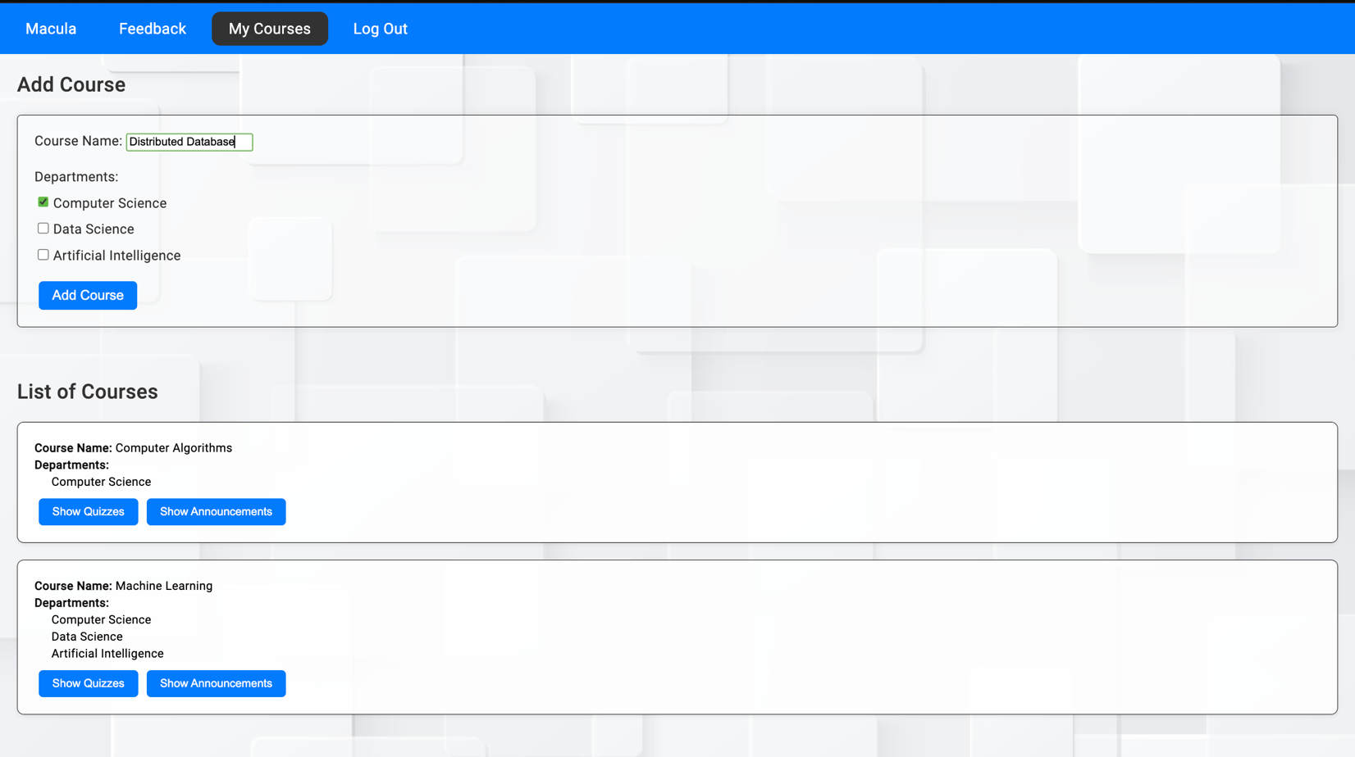

* All the courses which the professor has created can be visible.

**Add Quizzes**

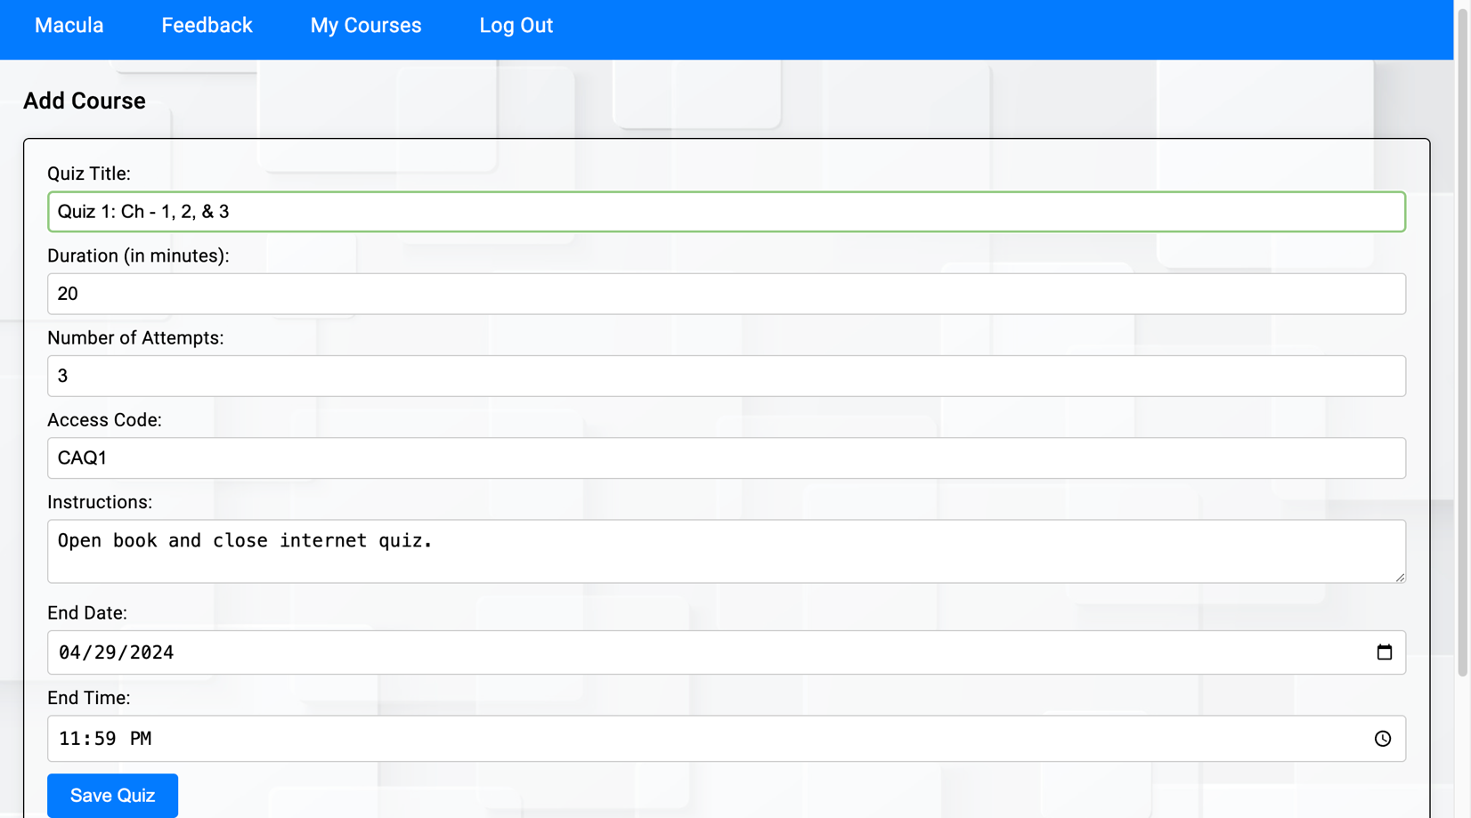

* The professor can create several quizzes for each course.

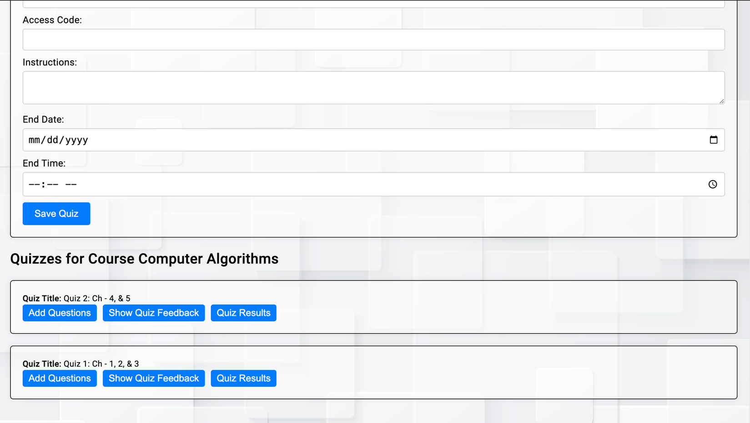

* The professor can see all the quizzes that he created

**Add Questions Page**

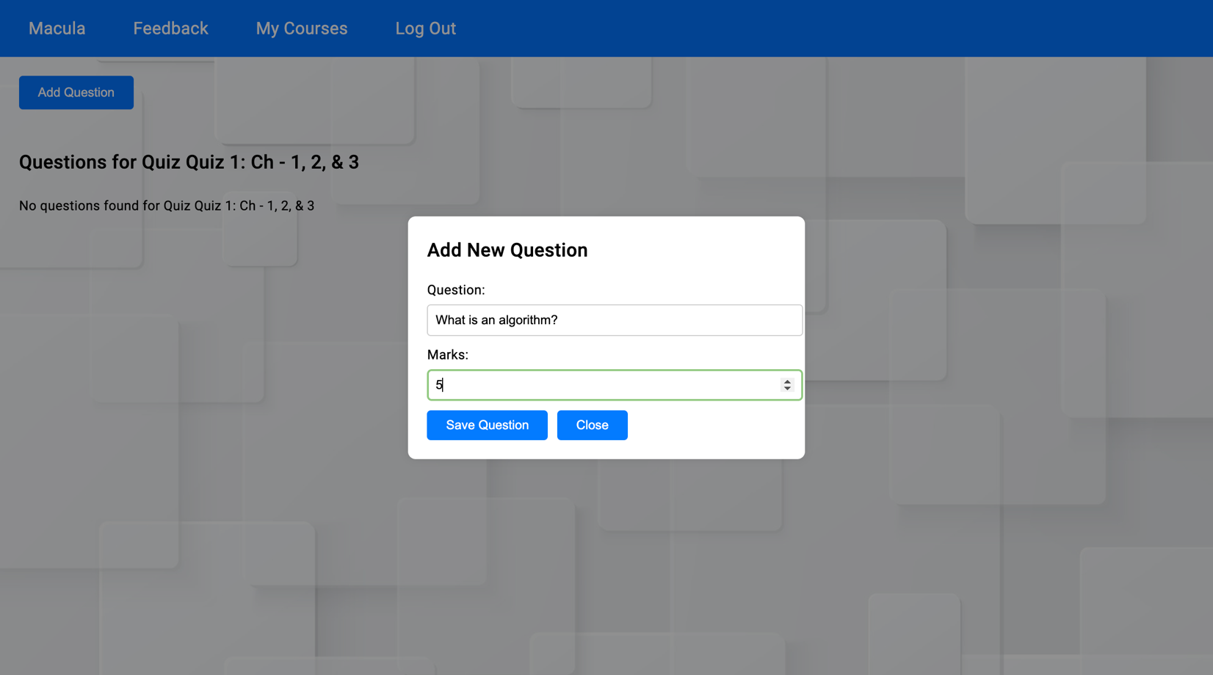

* The professor can add questions and assign marks to each question.

**Add Options**

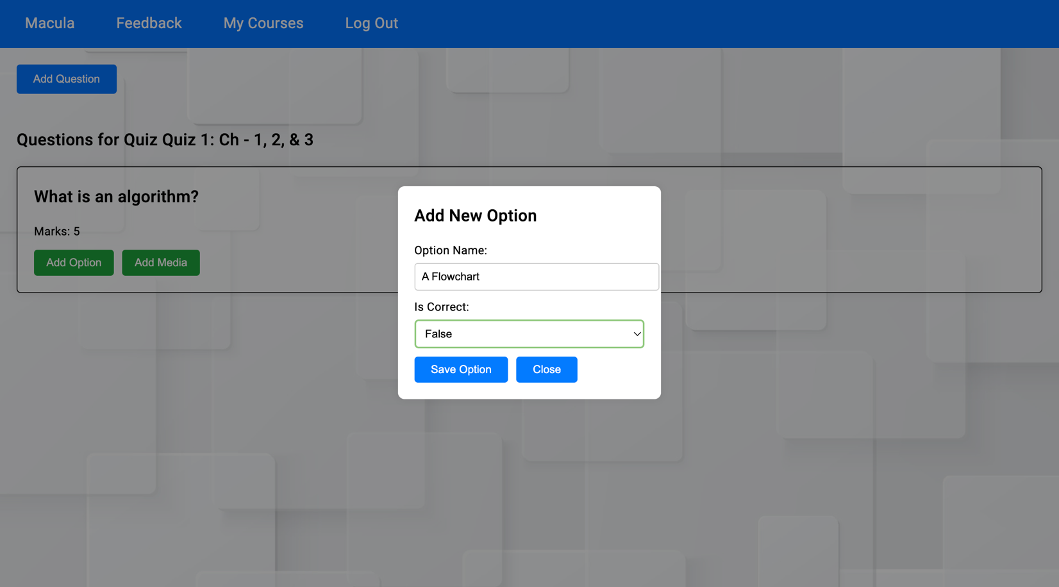

* The professor can add options to the questions.
* There is no limit on how many options to add for each question, that depends on the professor.
* For each option, the professor can decide whether it’s the correct answer or not.

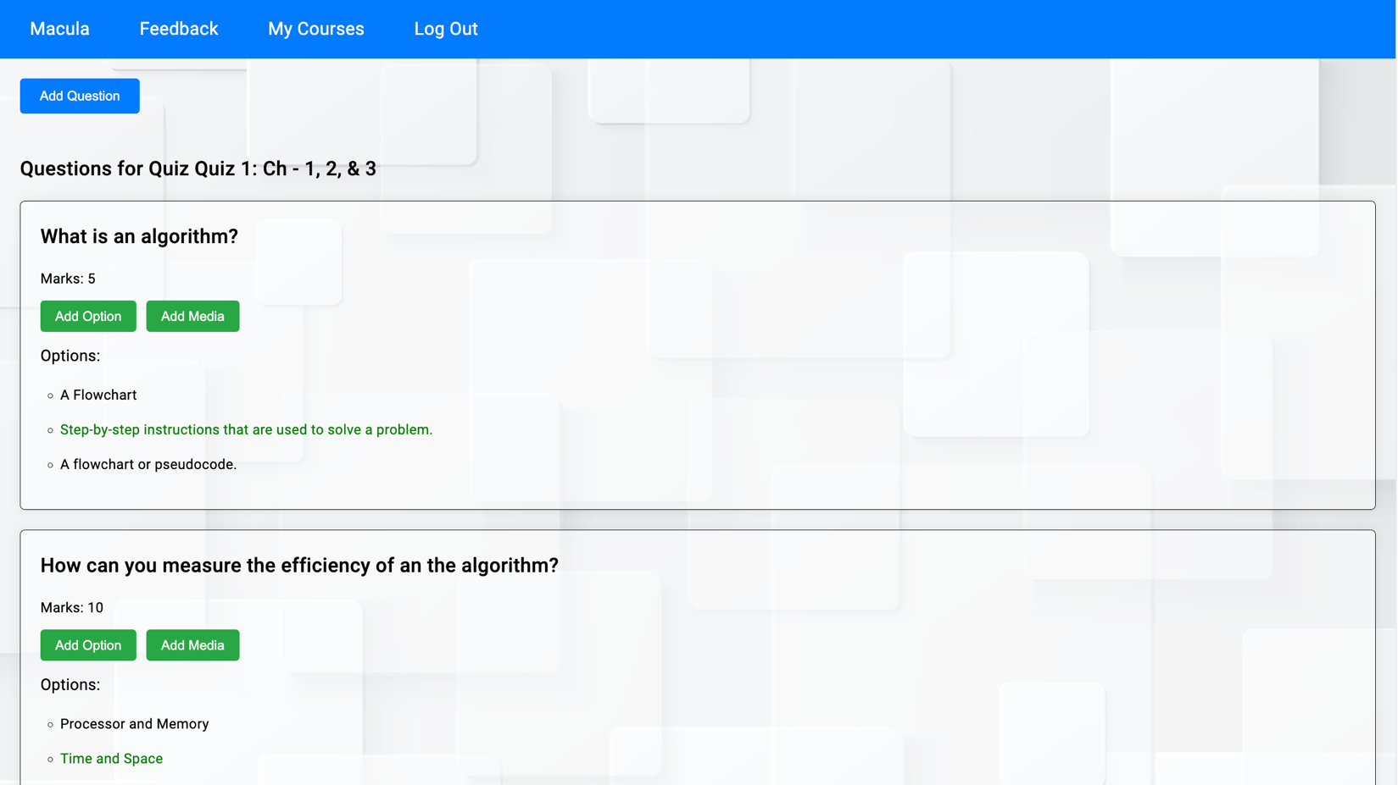

* All the correct answers are visible as green only to the professor.

**Add Media**

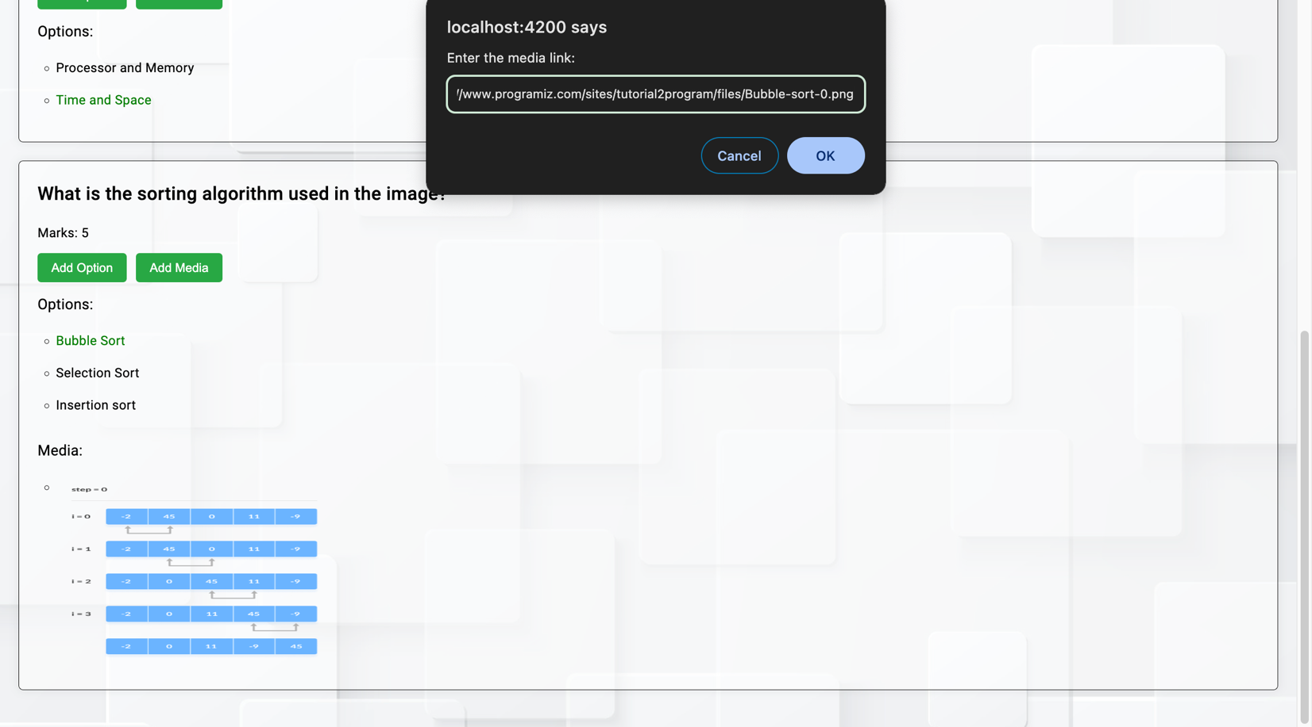

* For each question, the professor can add images.
* There can also be more than 1 image for a question.

**Course Page**

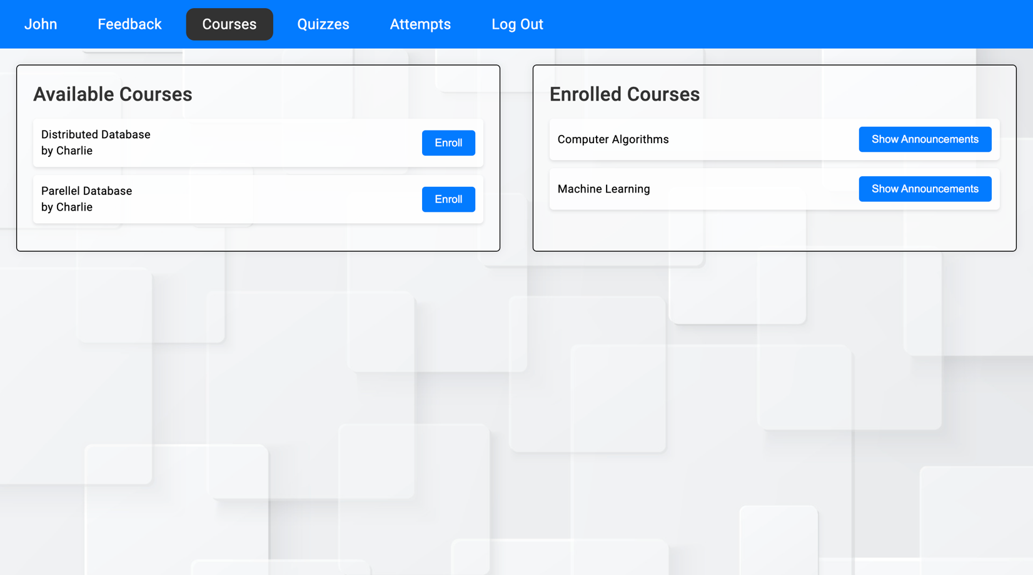

* Students can see and enroll in courses.
* The name of the professor is also visible who is taking that particular course.
* All the enrolled courses are displayed on the right, and all courses that can be enrolled are listed on the left.

**Quiz Page**

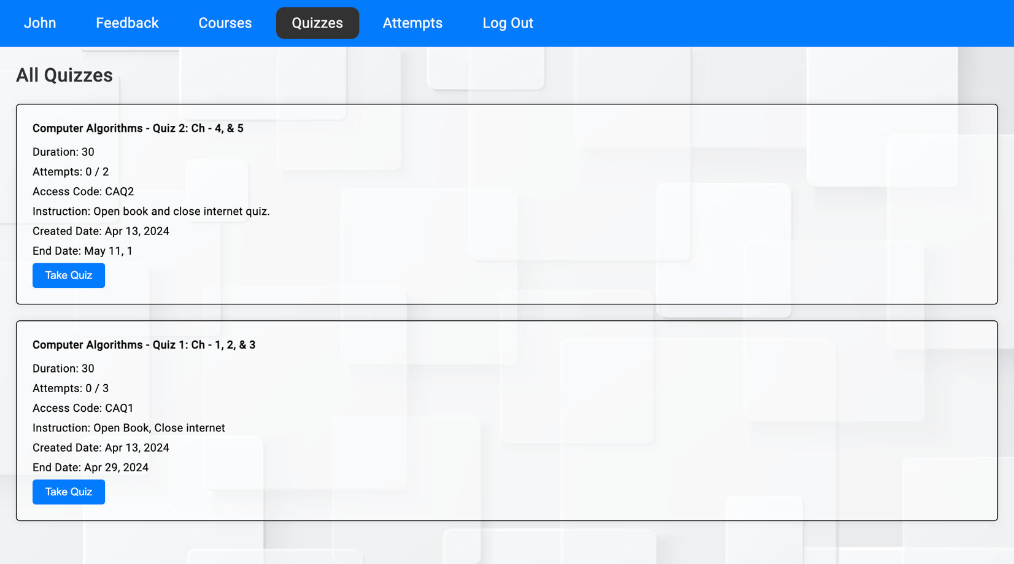

* All the quizzes are displayed on the quiz page.
* Only quizzes for the course that the user has enrolled in are visible.

**Take Quiz Page**

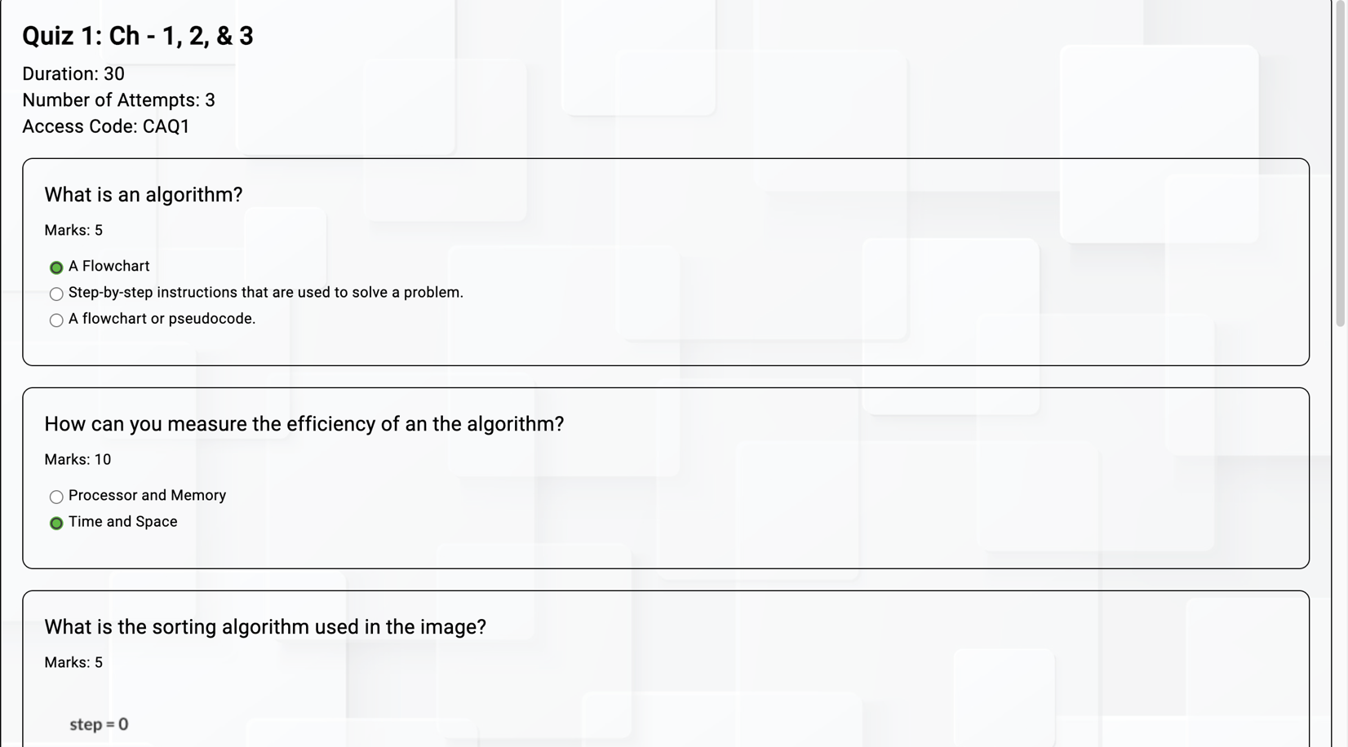

* Students can take the quiz

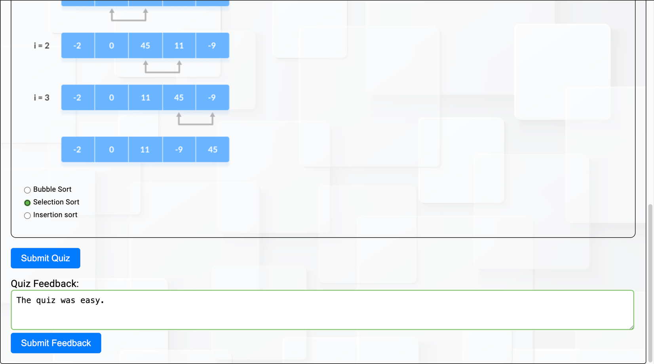

* Each student can also give feedback for a particular quiz before submitting the quiz.

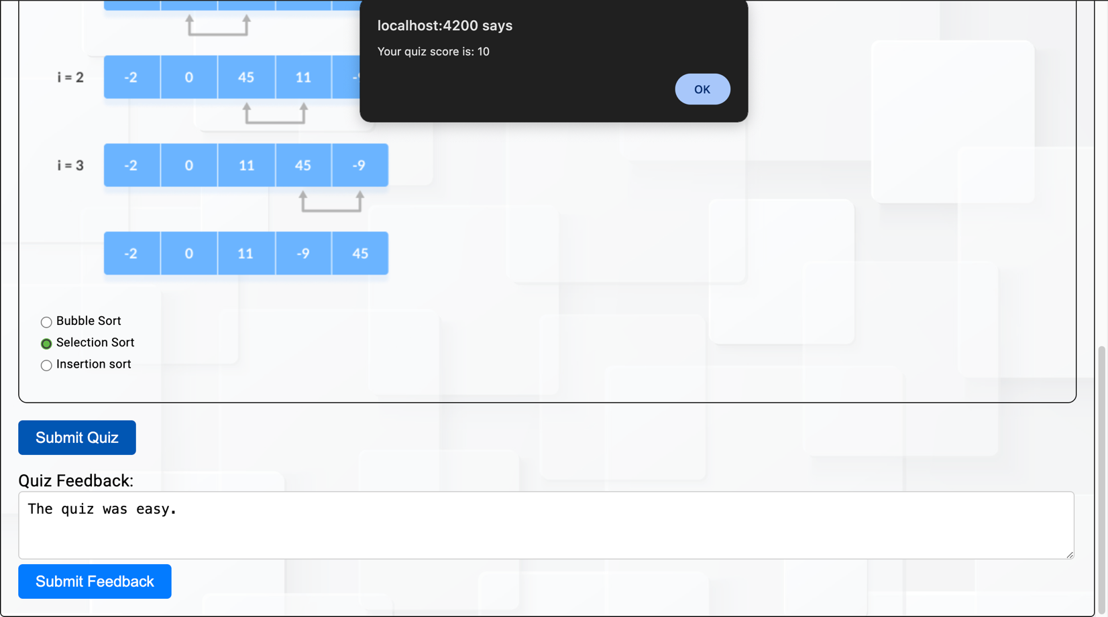

* Once the student submits the quiz, he/she can see the score.

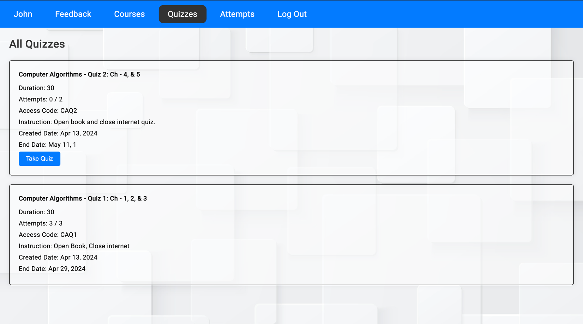

* Students can also see the number of attempts remaining for the quiz.
* If all the attempts are completed then the “Take Quiz” button is not visible, which means the student cannot attempt that quiz.

**Attempt History Page**

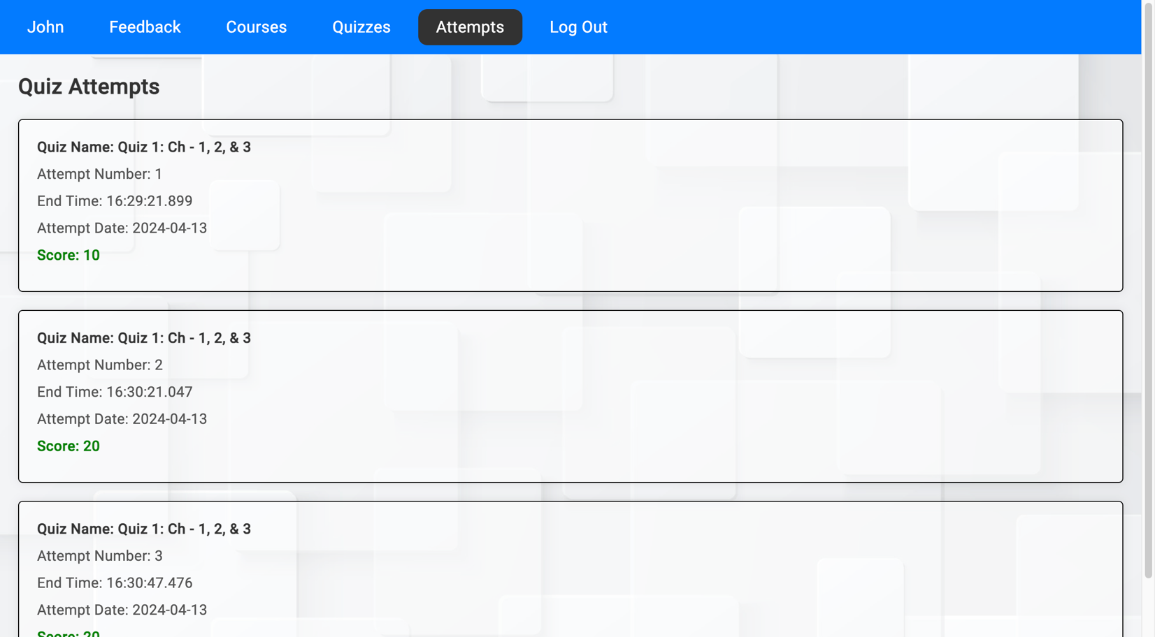

* All the attempts made by the student are visible on the attempts page.
* Data, time, and score of that particular attempt are displayed.

**View Quiz Feedbacks**

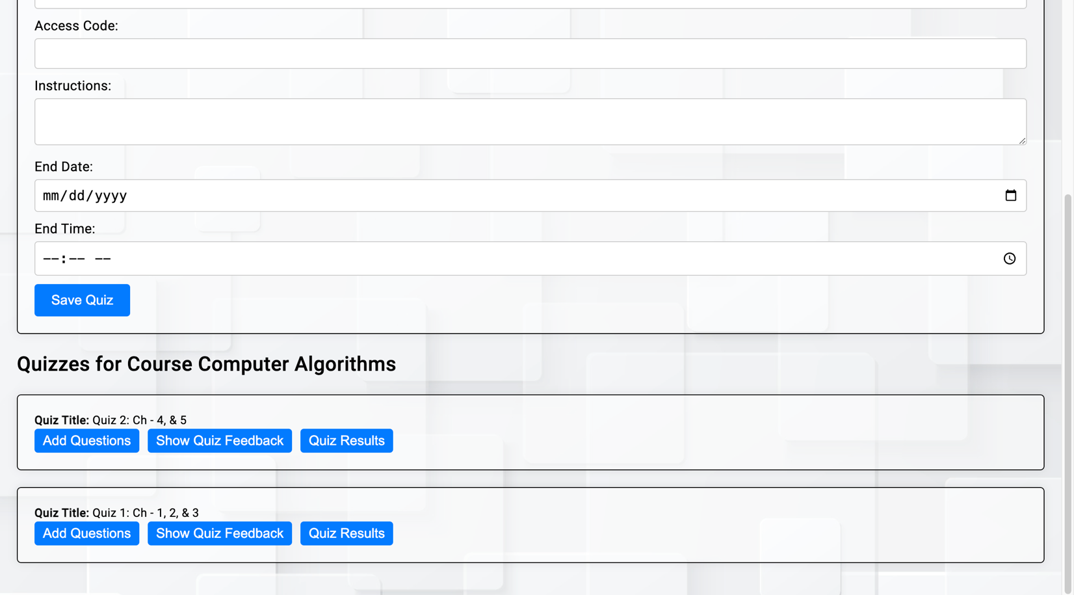

* The professor can click on the “Show Quiz Feedback” button to view all the feedback given by different students as shown below.

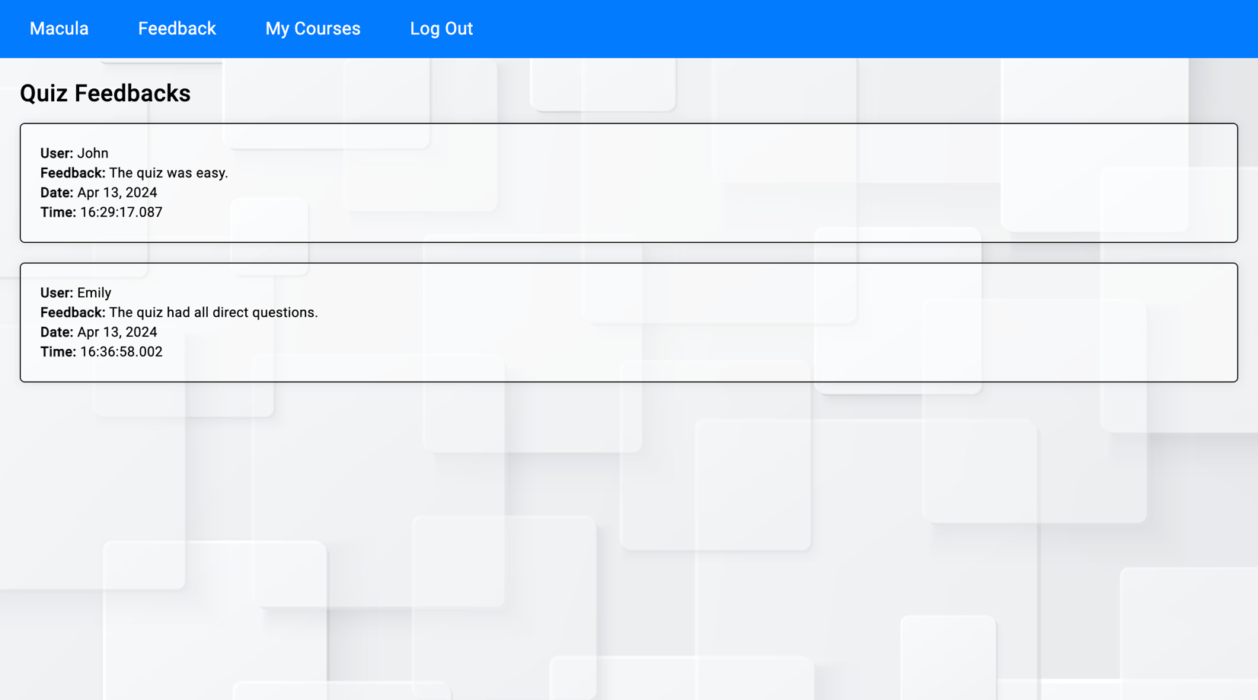

* The professor can see the feedback, who has given that feedback, and also the date and time on which the feedback is given.

**Quiz Results**

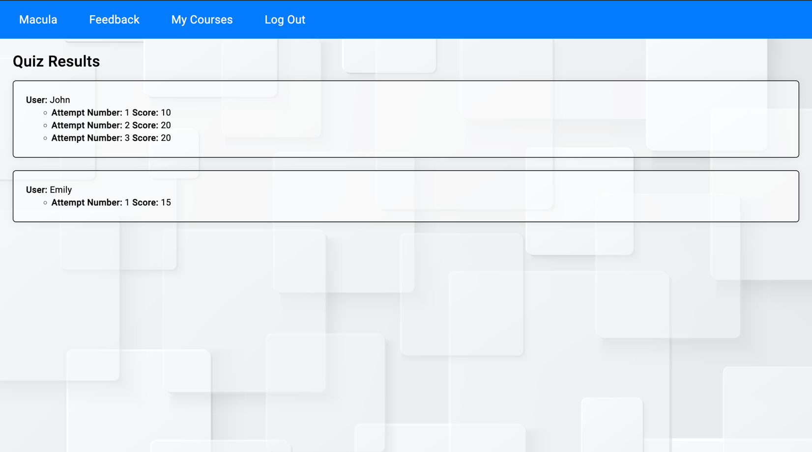

* The professor can also see all the student’s quiz results along with all the attempt scores separately.

**Add announcement**

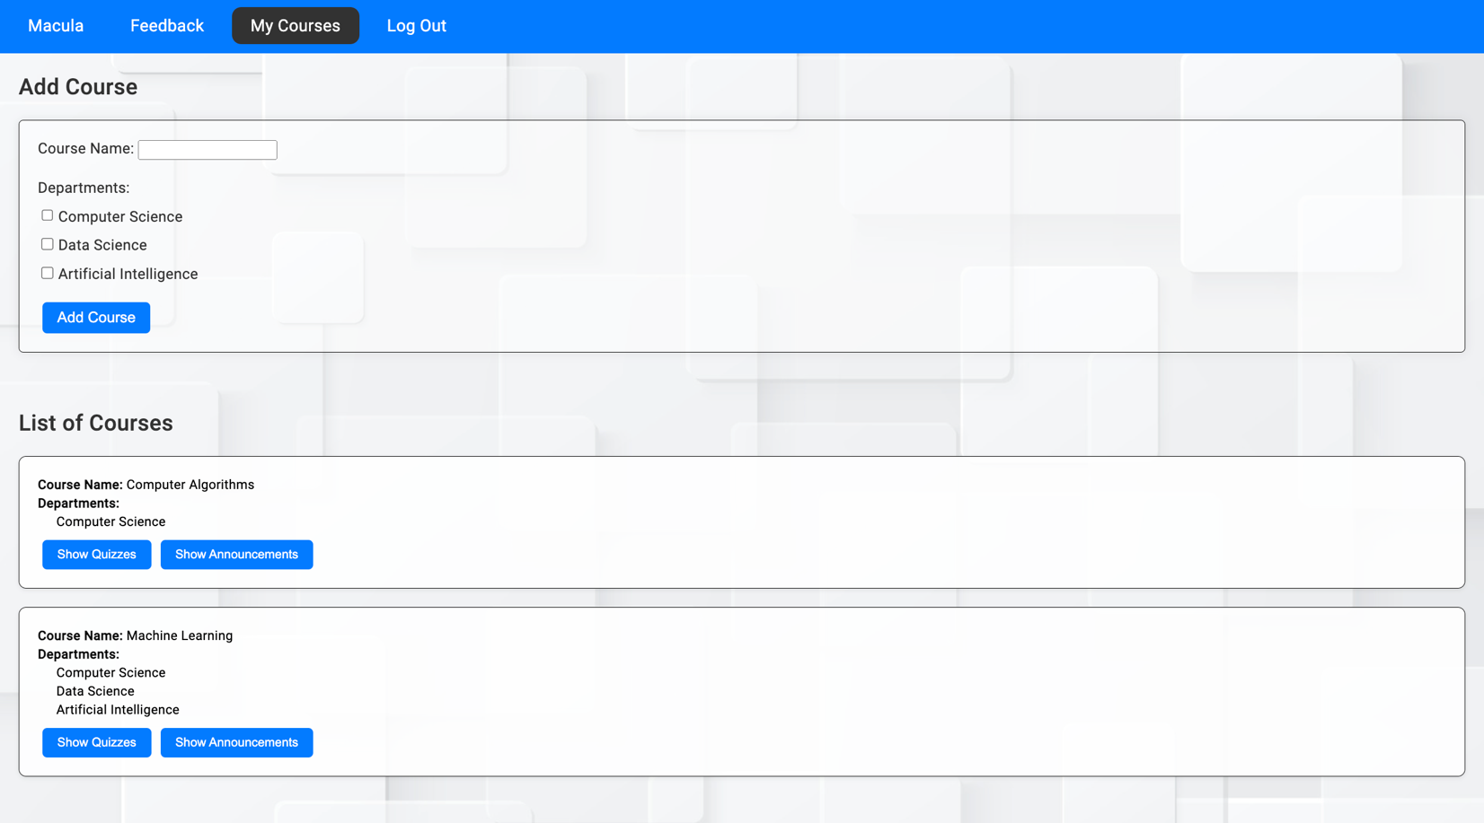

* Each course has its announcements.

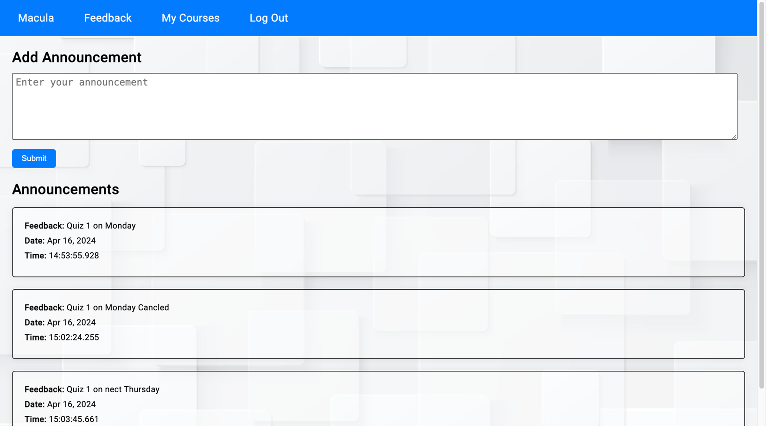

* The professor can add announcements for that particular course.

**View Announcement**



* Each course has a separate announcement.

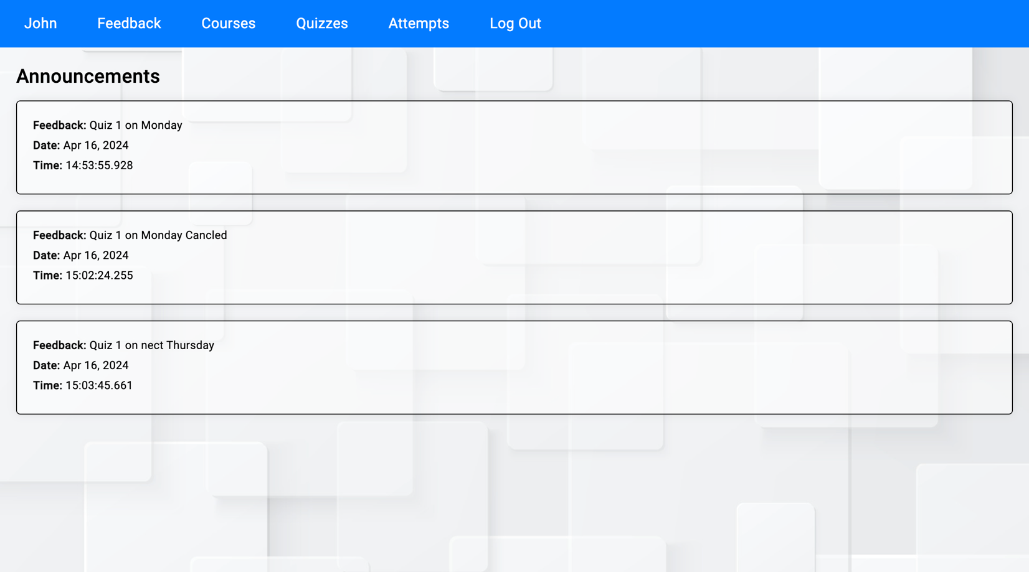

* Students can see announcements for courses including data and time.

**6. Conclusion:**

This project has achieved its objectives by providing a solution that improves the assessment process in educational institutes. This application is developed with interconnected database schema structures and the implementation of user-friendly interface interaction between professors and students.

This application allows instructors to create courses, quizzes, and announcements and students can enroll in courses, take quizzes, and view their results, and attempt history.

To maintain integrity and efficiency this system meets 1NF, 2NF, and 3NF.

One potential limitation could be scalability with a large number of users or concurrent quiz sessions.

There are many other potential applications of this database system like online testing platforms, employee training modules, or certification program tests. The complex and expandable database design makes the system indispensable in today’s digital age which offers solutions to a wide range of educational and organizational challenges.